Warm reminder

1 About testing your code
Your can preliminary test your code in here, http://pat.zju.edu.cn/contests/8. And the result will be like figure 1. But, it don’t means your code is completely correct. Because there is only one test case. Your code can’t be judged in 2014 Fundamentals of Data Structures - Judge.
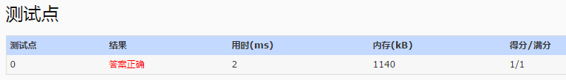
Figure 1：preliminary test result

2 About comment file
The file P2_comments.doc is the standard comment file. So, I think it will be some help to you to finish this project and report.

